Nombre: Período: Fecha: 4A vocab


¿Quieres ir conmigo?
Español 1

To talk about leisure activities:
To go shopping
To see a movie
Piano lesson (class) alone
I stay at home. To talk about when things are done:
To talk about places: ¿Cuándo?
Library afterwards
Café after
Countryside on weekends
Home, house on Mondays, On Tuesdays…..
At home free time
Mall To talk about where someone is from
Movie theater Where are you from?
Gym from, of
Church To indicate how often
Mosque generally
Mountains Other useful words and expressions
Park You don’t say!
Swimming pool in order to + infinitive
Beach Extra vocab pg. 472 ~ Los lugares y actividades
Restaurant bank: banco
Synagogue club: el club
Temple, Protestant church team: el equipo de….
Work, job pharmacy: la farmacia
To tell where you go: office: la oficina
To (prep.) practice: la práctica de…
To the meeting: la reunion , las reuniones
(to) where ? supermarket: el supermercado

(to) home
To tell with whom you go:
With whom?
With my/your friends
Gramática— irregular verb Práctica:
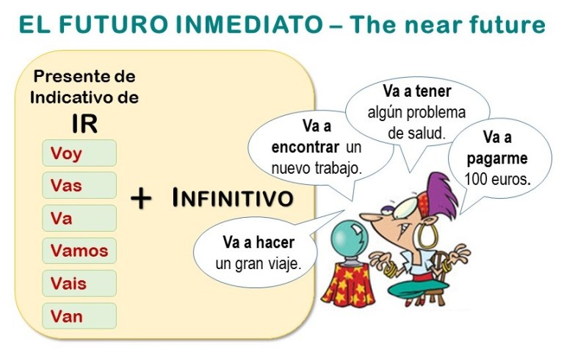
Ir: To go
- I go to the mall:
- We go to the bank:
- They go to the café:
- You (informal) go home:
- He is going to study.
- You all are going to swim at (en la) the beach.

Práctica:
- Where are you from?
- How old are you?
- WHy do you like to study?
- When do you arrive home?
- Which class is your favorite?
Asking questions/interrogatives:
What?
How? What?
Who?
With whom?
Where?
How much/many?
(to) where?
From where?
Which?, What?
Why?
When?

